The Jonas Andersson/Lundholm Family

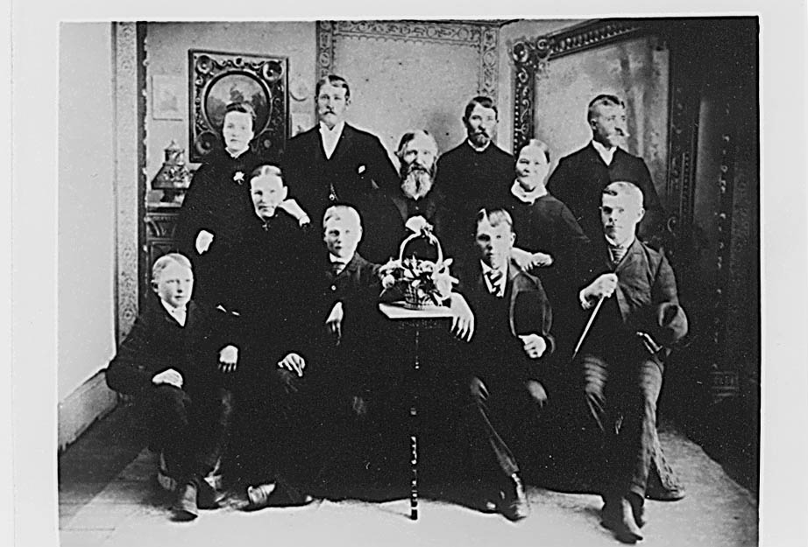
Top row: Anna Otilia Jonasdotter/Lundholm Ostrand, Oskar Leonard Jonasson/Lundholm, Carl Johan Jonasson/Lundholm, Peter August Jonasson/Lundholm. Middle row: Ida Christina Jonasdotter/Lundholm Swanson, Jonas Peter Anderson/Lundholm, Margareta Lisa Johannesdotter/Lundholm. Bottom row: Johannes Gustaf Jonasson, Otto Ferdinand Jonasson/Lundholm, Algot Theodore Jonasson/Lundholm, Adolph Fredrich Jonasson/Lundholm

